**POWER BI PROJECT REPORT**

**Session- 2024-25**

**on**

**Blinkit Sales Analysis Dashboard**



**Team Members (Group 1): Submitted to:**

Anushka Sharma – 2100680100079 Mr Madhvendra Singh Sir

Atirek Mani Diggal – 2100680100093

Vatsal Sharma – 2100680100343

**Project Overview:**

This Power BI project focuses on analyzing Blinkit's sales performance, customer satisfaction, and inventory distribution using various datasets. The aim is to generate insights into the impact of product attributes and customer feedback on overall sales.

* **Table 1**: Contains key sales data, including **Item Fat Content**, **Item Identifier**, **Item Type**, **Outlet Establishment Year**, **Outlet Identifier**, **Outlet Location Type**, **Outlet Location**, **Outlet Type**, **Item Visibility**, **Item Weight**, **Sales**, and **Rating**. This table provides information about the items sold and the characteristics of the outlets where sales occurred.
* **Table 2**: Contains product-specific review data, including **Product ID**, **Product Name**, **Review Score**, and **Review Count**. This table captures customer feedback and product popularity through reviews and ratings.

**Data Cleaning:**

Data cleaning was a crucial step in ensuring the accuracy and usability of the analysis. The following steps were taken:

1. **Handling Missing Values:** Missing data in product and outlet fields were handled by either filling in relevant information or excluding non-essential columns from the analysis.
2. **Data Type Conversion:** Converted numeric fields like total sales, item counts, and ratings to appropriate data types to ensure consistency.
3. **Date Format Standardization:** Standardized date fields across datasets to enable accurate time-based analysis.
4. **Duplicate Removal:** Removed duplicate sales records to prevent biased or skewed analysis.

These steps ensured that the data was clean, consistent, and ready for analysis.

**Data Modeling:**

The data modeling involved creating relationships between the various datasets to support meaningful analysis. The primary and foreign keys (PK and FK) and relationships were defined as follows:

* **Table 1**: The **Item Identifier** serves as the primary key and is linked to product-related data in other analyses, such as performance by item type and fat content.
* **Table 2**: The **Product ID** is the primary key, linked to the **Item Identifier** in Table 1 to combine product-specific attributes like **Review Score** and **Review Count** with sales data.

These relationships enabled a cohesive data model, allowing for insightful visualizations related to sales performance, product attributes, customer satisfaction, and outlet distribution.

**Visualizations:**

The visualizations in this Power BI project include the following:

1. **Total Sales by Fat Content**:
   * **Objective**: Analyze the impact of fat content on total sales.
   * **Chart Type**: Donut Chart.
2. **Total Sales by Item Type**:
   * **Objective**: Assess item type performance and contribution to overall sales.
   * **Chart Type**: Bar Chart.
3. **Fat Content by Outlet for Total Sales**:
   * **Objective**: Compare sales by fat content across different Blinkit outlets.
   * **Chart Type**: Stacked Column Chart.
4. **Total Sales by Outlet Establishment**:
   * **Objective**: Investigate the influence of outlet age and type on sales.
   * **Chart Type**: Line Chart.

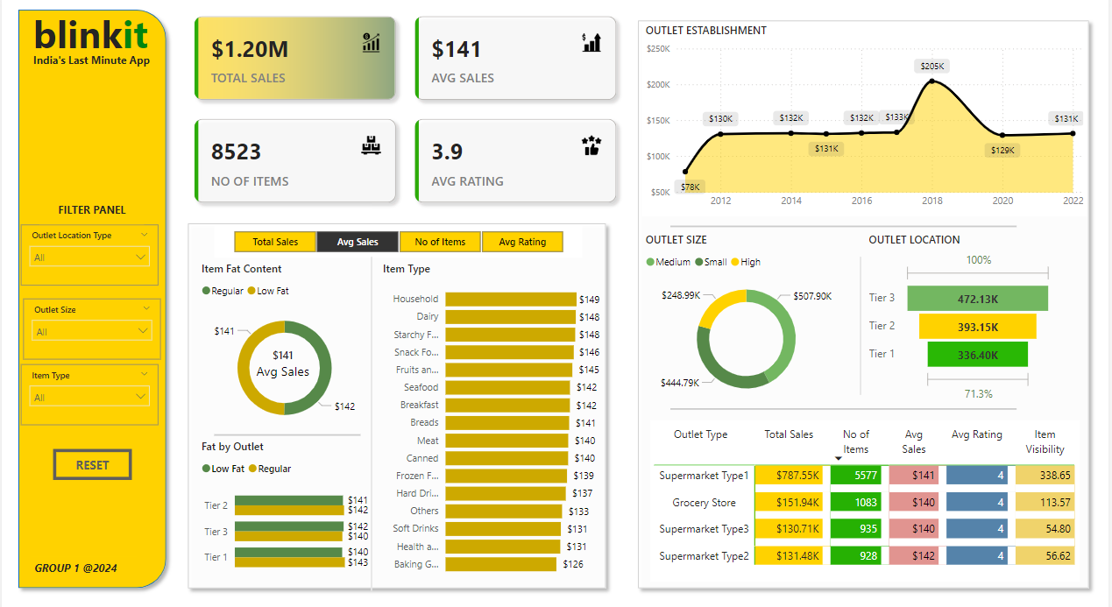

Fig.1 :- Sales Analysis in a all tiers

**Conclusions and Findings:**

The analysis provided several valuable insights:

1. **Sales Performance by Fat Content**: Certain fat content types had a significant influence on sales volume, with high-fat products performing particularly well in specific outlets.
2. **Item Type Impact**: Products of certain item types (e.g., snacks and beverages) contributed heavily to overall sales.
3. **Outlet Age and Sales**: Older, more established outlets exhibited higher sales, possibly due to increased customer trust and loyalty.
4. **Customer Satisfaction**: The average rating metric highlighted strong customer satisfaction across most products, indicating a positive customer experience.

These findings can help Blinkit optimize product offerings, inventory distribution, and outlet strategies to maximize sales performance and customer satisfaction.